

**CO2MOVINGJET**

Moving Head CO2 Jet

**USER MANUAL**

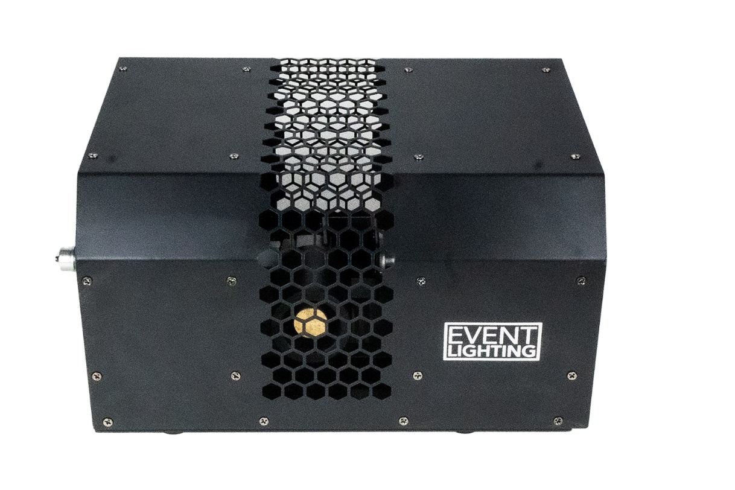

**For your safety, please read this user manual carefully before use.**

Event Lighting reserves the right to revise the manual at any time. Information and specifications within this manual are subject to change without notice. Event Lighting assumes no liability or responsibility for any errors or omissions. Please consult Event Lighting for any clarification or information regarding this item.

Version 1.0

# Safety Instructions

* Do not setup this product within 3m towards any people or animals.
* Ensure there are no loose objects in the directions of this product which can be damaged.
* Ensure the CO2 bottle is placed upright on a secure surface.
* Do not operate in any location where dust, excessive heat, water or humidity may affect the product.
* Do not operate this device if the housing, cables or hoses appear damaged.

# Usage Instructions

* Place this product in desired and safe position
* Connect any DMX cabling
* Connect one end of the CO2 hose to the CO2 bottle and the other end to the GAS IN port on the product.
* Open the valve on the CO2 bottle and **check for any pressure leaks**.
* Switch on the product.

**Note.** To test that CO2 connection is correct, you will hear a clicking sound (magnetic valve) when switching on and off the product.

* CO2MOVINGJET is now ready for use.

**IMPORTANT**

After use, close the valve and release any gas remaining in the hose before turning off the power and disconnecting the hoses.

**DMX**

|  |  |  |  |
| --- | --- | --- | --- |
| **DMX Channels** | **Value** | **Function** | **Description** |
| 1 | 0-255 | Tilt | 0-180 deg |
| 2 | 0-1 | Trigger | Trigger On/Off |
| 3 | 0-1 | Auto | Automatic Jet Trigger On/Off |
| 4 |  | Position auto trigger | Trigger ch.1 slow to fast |
| 0-10 | No function |  |
| 10-255 | Slow to fast |  |
| 5 | 0-255 | Auto Speed | Auto trigger ch.3 speed fast to slow |

# Technical Specifications

* Input Voltages: 220V~240V AC,50/60Hz
* Power Consumption: 150W
* Power Connection: True1 in/out
* Control Mode: DMX 5ch
* Spray Distance: 8 m - 10 m
* Maximum Pressure, 1400 psi
* Head Swing Range: 180 deg
* Net Weight: 10.7
* Dimensions: 360 X 253 X 283 mm

# Warranty

Please refer to your local dealer or contact Event Lighting.